

**SANYO SA-KC9BG3**

**Rs. 98,100/-**

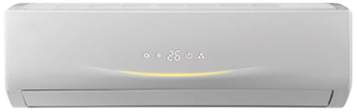

**Product Features**

* friendly referigerant R410a
* auto restart after power restored
* High Temperature Stable Running work upto 52C (T3 condition)
* Antifouling and Movable Baffle
* Compact Design

**Specification**

**Type** Wall Mounted Split AC

**Cooling (Btu/h)** 53000

**Voltage (V)** 220-240

**Power Input (W)** 4100

**EER (Btu/W-h-W/W)** 7.1-2.4